ECA5802-IOE AND AI DRIVEN SYSTEM
EXPERIMENT 6(a):SIMULATION AND PERFORMANCE EVALUATION OF PEOPLE-PROCESS-DATA-THINGS IOE FRAMEWORK USING EDGE/FOG TO CLOUD PIPELINE WITH MQTT,NODE-RED.

OBJECTIVES:
- To simulate the People-Process-Data-Things (PPDT) IoE framework using Node-RED and MQTT.
- To establish communication between edge, fog, and cloud layers for efficient data transmission.
- To monitor and analyse data flow, processing performance, and communication reliability.
- To evaluate the effectiveness of IoE integration in improving real-time monitoring and decision-making.

SOFTWARE REQUIRED:
Node.js,Node RED,Escllipe Mosquitto

PROGRAM CODE:
let ids = [
"RFID001",
"RFID002",
"NFC003",
"RFID004",
"UNKNOWN999"
];

let n = (flow.get("scanNumber") || 0) + 1;
flow.set("scanNumber", n);

let tag = ids[(n - 1) % ids.length];

msg.topic = "ioe/device/scan";

msg.payload = {
tag_id: tag,
device_id: "DEV-" + tag,
timestamp: Date.now(),
temperature: Number(
(25 + Math.random() * 10).toFixed(2)
),
status: "scan"
};

return msg;

Reader

let data = msg.payload;

if (typeof data === "string") {
try {
data = JSON.parse(data);
} catch (e) {
return null;
}
}

if (!data || !data.tag_id || !data.timestamp) {
return null;
}

let allowed = [
"RFID001",
"RFID002",
"NFC003",
"RFID004"
];

let valid = allowed.includes(data.tag_id);

let received = (flow.get("receivedCount") || 0) + 1;
flow.set("receivedCount", received);

let validCount = flow.get("validCount") || 0;
let invalidCount = flow.get("invalidCount") || 0;

if (valid) {
validCount++;
flow.set("validCount", validCount);
} else {
invalidCount++;
flow.set("invalidCount", invalidCount);
}

let latency = Math.max(0, Date.now() - data.timestamp);

let sum = (flow.get("latencySum") || 0) + latency;
flow.set("latencySum", sum);

let start = flow.get("testStart");
if (!start) {
start = Date.now();
flow.set("testStart", start);
}

let elapsed = Math.max((Date.now() - start) / 1000, 0.001);

msg.payload = {
tag_id: data.tag_id,
device_id: data.device_id,
identified: valid,
temperature: data.temperature,
latency_ms: latency,
received_count: received,
valid_count: validCount,
invalid_count: invalidCount,
throughput_msg_per_sec: Number(
(received / elapsed).toFixed(2)
),
avg_latency_ms: Number(
(sum / received).toFixed(2)
)
};

return msg;

OUTPUT:
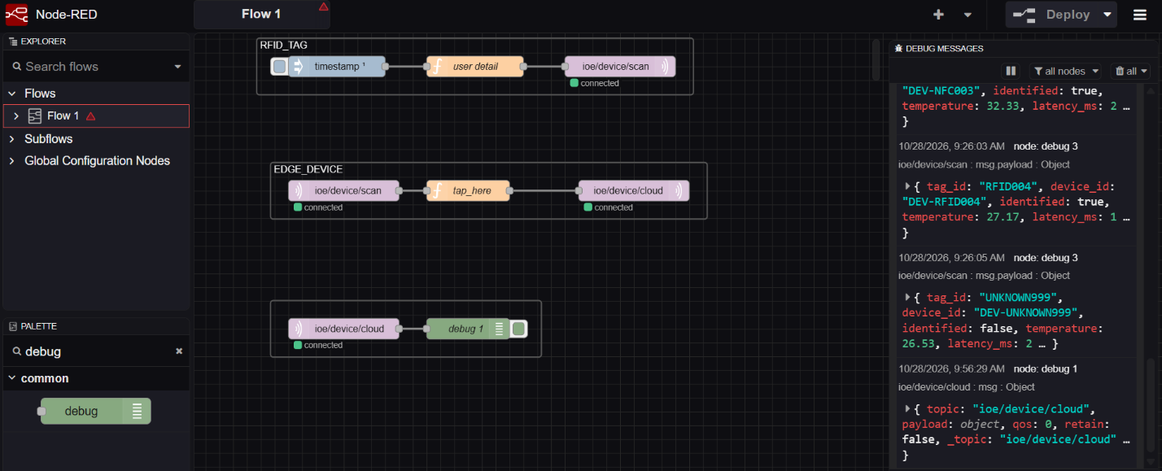

RESULT:

The People-Process-Data-Things IoE framework was successfully simulated using Node-RED and MQTT. Data transmission through the edge/fog-to-cloud pipeline was evaluated, demonstrating effective data integration, monitoring, and processing across the IoE layers.

